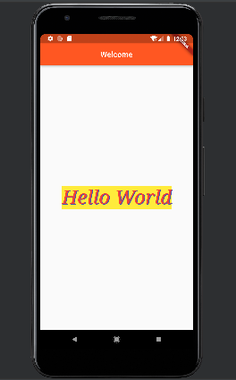

import "package:flutter/material.dart";  
void main(){  
 runApp(MyApp());  
}  
class MyApp extends StatelessWidget {  
 const MyApp({Key? key}) : super(key: key);  
  
 @override  
 Widget build(BuildContext context) {  
 return MaterialApp(  
 home: Scaffold(  
 appBar: AppBar(  
 backgroundColor: Colors.*deepOrange*,  
 centerTitle: true,  
 title: Text("Welcome"),  
 ),  
 body: Center(  
  
 child: Text("Hello World", style: TextStyle(  
 fontSize: 50,  
 fontFamily: "Times New Roman",  
 fontStyle: FontStyle.italic,  
 color: Colors.*red*,  
 backgroundColor: Colors.*yellow*,  
 shadows: [Shadow(color:Colors.*indigo*, offset: Offset(2,1))]  
 ),) ,  
 ),  
 ),  
 );  
 }  
}

import "package:flutter/material.dart";  
void main(){  
 runApp(MyApp());  
}  
class MyApp extends StatelessWidget {  
 const MyApp({Key? key}) : super(key: key);  
  
 @override  
 Widget build(BuildContext context) {  
 return MaterialApp(  
 home: Scaffold(  
 appBar: AppBar(  
 backgroundColor: Colors.*deepOrange*,  
 centerTitle: true,  
 title: Text("Welcome"),  
 ),  
 body: Row(  
 children: [  
 Container(  
  
 child: Text("Hello World", style: TextStyle(  
 fontSize: 30,  
 fontFamily: "Raleway",  
 fontStyle: FontStyle.italic,  
 color: Colors.*red*,  
 backgroundColor: Colors.*yellow*,  
 shadows: [Shadow(color:Colors.*indigo*, offset: Offset(2,1))]  
 ),) ,  
 ),  
 SizedBox(  
 height: 25,  
 width: 10,  
 ),  
 Container(  
 child: Text("App", style: TextStyle(  
 fontSize: 30,  
 fontFamily: "Raleway",  
 fontStyle: FontStyle.italic,  
 color: Colors.*red*,  
 backgroundColor: Colors.*yellow*,  
 shadows: [Shadow(color:Colors.*indigo*, offset: Offset(2,1))]  
 ),) ,  
  
 ),  
 Container(  
 child: Icon(Icons.*adb_rounded*),  
 )  
 ],  
 ),  
 ),  
 );  
 }  
}

